3346 Assignment 1

Zaid Albirawi  
250626065

1. Section 2.3 (Page 50) argued that it was impossible to build a representation of a world that is independent of what the agent will do with it. This exercise lets you evaluate this argument.   
    Choose a particular world, for example, what is on some part of your desk at the current time.  
     
   World: Desk I am on.
   1. Get someone to list all of the things that exist I this world (or try it yourself as a thought experiment).
      * Calculator
      * Energy drink
      * iPod
      * Laptop
      * Pencil case
      * Text book
      * Bus pass
      * Headphones
      * Yoyo yogurt
      * Subway
      * Cellphone
      * Gum
      * Cookies
      * Laptop charger
      * Car keys
      * Cigarettes
      * Colon
      * Water bottle
      * Notebook
   2. Try to think of twenty things they missed. Make these as different from each other as possible. For example, the ball at the tip of the rightmost ballpoint pen on the desk, or the spring in the stapler, or the third word on page 66 of a particular book on the desk.
      * Liquid ink fine tip pen
      * In-ear beats headphones
      * Power supply
      * Highlighter
      * Privilege, power, and difference book
      * Spoon
      * Subway cookie bag
      * E-cigarette
      * MacBook Pro sleeve
      * iPod charger
      * USB cable
      * Straw wrapper
      * Worlds gym membership card
      * Ivey case book
      * Light bulb
      * Leaf on the subway bag
      * Ivey logo
      * LG G3 phone case
      * Pen cap
      * Change ahead sign on the Ivey Personal Career Management book
   3. Try to find a thing that cannot be described using natural language.  
      For a thing to exist in a world it has to be describable in natural language. Therefore, there does not exist a thing that cannot be described in natural language.
   4. Choose a particular task, such as making the desk tidy, and try to write down all the things in the world at a level of description that is relevant to this task.  
        
      Task: Backup my belongings and put them neatly into my bag.
      * Identify my belongings.
      * Find where each of these belongings will fit into the bag.
      * Start collecting the belongings one by one and inserting them neatly into the bag.
      * If a belonging is trapped under something, or is being used by friend then delay the operation and process the next item.
      * When finished packing the items in the bag, have another look at the table and collect all left over items. If the item is trapped under another then find a way to obtain that item, without making a mess. If the item is being used by friend, ask that friend for the item, and wait for him to return it.
      * When the process is done close the bag.

Based on this exercise, discuss the following statements.

1. What exists in a world is a property of the observer.  
   If the observer has no knowledge of an object or an agent in a world then, to the observer, that object does not exist in the world. However, if the observer knows of that object’s existence then that object exists in the observer’s world.
2. We need ways to refer to individuals other than expecting each individual to have separate name.  
   If we rely on names to differ between objects we might have a situation where two objects have the same name, therefore, those objects are not differentiable. While if we differ between objects based on their characteristics we will be able to determine if those objects are similar or different.
3. What individuals exist is a property of the task as well as of the world.  
   If the individuals or objects do not affect the task or the world then their existence is needless, because the agent does not need to know of them or communicate/perform operations on/with them.

|  |  |  |  |  |  |  |  |
| --- | --- | --- | --- | --- | --- | --- | --- |
|  |  |  |  |  |  |  |  |
|  |  |  |  |  |  |  |  |
|  |  | g |  |  |  |  |  |
|  |  |  |  |  |  |  |  |
|  |  |  |  |  |  |  |  |
|  |  |  | s |  |  |  |  |
|  |  |  |  |  |  |  |  |
|  |  |  |  |  |  |  |  |

1. To describe the individuals in a domain, you need what is essentially a dictionary of a huge number of words and ways to combine them to describe individuals, and this should be able to be done independently of any particular domain.  
   For an agent to be able to differ between objects the agent will have to categorize these objects based on their characteristics and to be able to do such thing, the agent mush have a dictionary that contains a set of characteristics that can be associated with objects.
2. Consider the problem of finding a path in the grid shown from the position *s* to the position *g*. A piece can move on the grid horizontally and vertically, one square at a time. No step may be made into a forbidden shaded area.

|  |  |  |  |  |  |  |  |
| --- | --- | --- | --- | --- | --- | --- | --- |
| 17 | 16 | 15 | 14 | 13 | 12 | 11 | 10 |
| 18 | 19 | 20 | 21 | 22 | 23 | 24 | 9 |
|  |  | g | 28 | 27 | 26 | 25 | 8 |
|  |  |  |  |  |  |  | 7 |
|  |  | 2 | 1 | 3 | 4 | 5 | 6 |
|  |  |  | s |  |  |  |  |
|  |  |  |  |  |  |  |  |
|  |  |  |  |  |  |  |  |

* 1. On the grid shown, number the nodes expanded (in order) for a depth-first search from *s* to *g*, given that the order of the operators is up, left, right, then down. Assume there is a cycle check.  
       
     The order that the algorithm takes is denoted by the numbers 1-28 on the grid shown. The path that the algorithm took is as follows, starting at S, where U=Up, L=Left, R=Right, and D=Down.  
       
     U, L, R, R, R, R, U, U, U, U, L, L, L, L, L, L, L, D, R, R, R, R, R, R, R, D, L, L, L, L, L.

|  |  |  |  |  |  |  |  |
| --- | --- | --- | --- | --- | --- | --- | --- |
|  |  |  |  |  |  |  |  |
|  |  |  |  |  |  |  |  |
| 14 | 15 | g |  |  |  |  |  |
| 13 |  |  |  |  |  |  |  |
| 12 |  | 2 | 1 | 3 | 4 |  |  |
| 11 | 10 |  | s | 5 |  |  |  |
|  | 9 | 7 | 6 |  |  |  |  |
|  |  | 8 |  |  |  |  |  |

* 1. For the same grid, number the nodes expanded, in order, for a best-first search from *s* to *g*. Manhattan distance should be used as a the evaluation function. The Manhattan distance between two points is the distance in the *x*-direction plus the distance in the *y*-direction. It corresponds to the distance traveled along city streets arranged in a grid. Assume multiple-path pruning. What is the first path found?  
       
     The path found is 6, 7, 9, 10, 11, 12, 13, 14, and 15.

|  |  |  |  |  |  |  |  |
| --- | --- | --- | --- | --- | --- | --- | --- |
|  |  |  |  |  |  |  |  |
|  |  |  |  |  |  |  |  |
|  |  | g | 13 | 12 | 11 | 10 | 9 |
|  |  |  |  |  |  |  | 8 |
|  |  | 2 | 1 | 3 | 4 | 5 | 7 |
|  |  |  | s |  |  |  |  |
|  |  |  |  |  |  |  |  |
|  |  |  |  |  |  |  |  |

* 1. On the same grid, number the nodes expanded, in order, for heuristic depth-first search from s to g, given Manhattan distance as the evaluation function. Assume a cycle check. What is the path found?  
       
     The path found is 1, 3, 4, 5, 7, 8, 9, 10, 11, 12, and 13.

|  |  |  |  |  |  |  |  |
| --- | --- | --- | --- | --- | --- | --- | --- |
|  |  |  |  |  |  |  |  |
|  |  |  |  |  |  |  |  |
| 22 | 23 | g |  |  |  |  |  |
| 21 |  |  |  |  |  |  |  |
| 20 |  | 2 | 1 | 3 | 7 | 14 |  |
| 19 | 13 |  | s | 4 | 8 |  |  |
| 18 | 12 | 6 | 5 | 9 | 15 |  |  |
|  | 17 | 11 | 10 | 16 |  |  |  |

* 1. Number the nodes in order for an A* search, with multiple-path pruning, for the same graph. What is the path found?  
       
     The path found is 5, 6, 12, 13, 19, 20, 21, 22, and 23.

1. 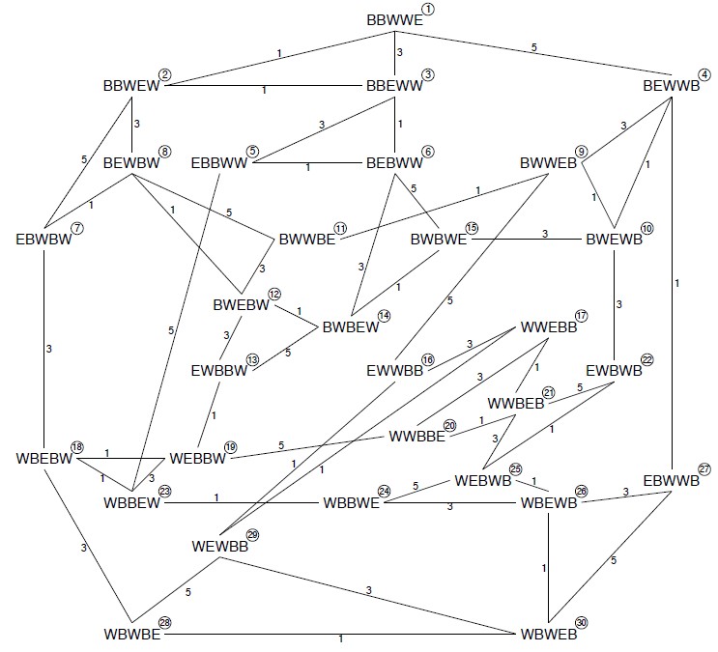Consider a puzzle whose complete move graph (each node represents a configuration of the puzzle each edge represents a move) is given in the diagram on the following page. The initial configuration is **Node 20** (WWBBE). **Note that this node is near the center of the graph.**   
     
   The puzzle has a cost associated with each move (1, 3, or 5) and these costs are indicated on the edges. The goal of the puzzle is to reach one of the **Nodes 3, 9, 10, 11, or 27.**  
   Give the search tree produced by an A* search which uses multipath pruning. Since this tree grows dynamically, you should annotate the tree with f-values used and any other comments such as indicating the order that nodes are taken from the priority queue and the reason for pruning.

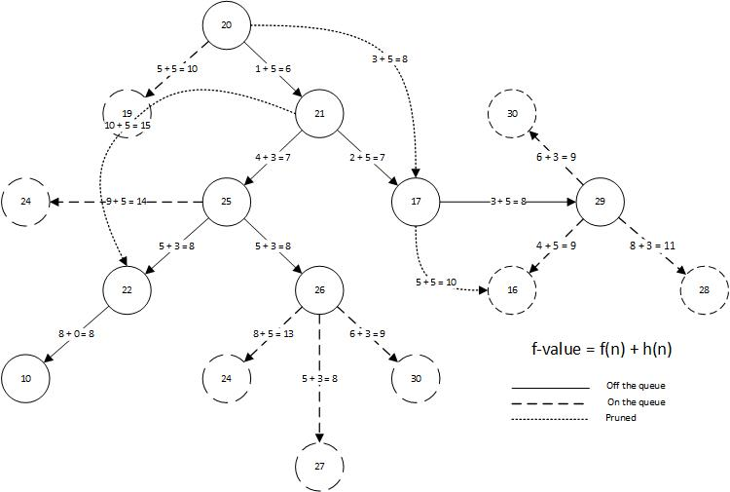

|  |  |
| --- | --- |
| Node | h |
| 1 | 5 |
| 2 | 5 |
| 3 | 5 |
| 4 | 0 |
| 5 | 5 |
| 6 | 5 |
| 7 | 3 |
| 8 | 3 |
| 9 | 0 |
| 10 | 0 |
| 11 | 0 |
| 12 | 3 |
| 13 | 5 |
| 14 | 3 |
| 15 | 3 |
| 16 | 5 |
| 17 | 5 |
| 18 | 5 |
| 19 | 5 |
| 20 | 5 |
| 21 | 5 |
| 22 | 3 |
| 23 | 5 |
| 24 | 5 |
| 25 | 3 |
| 26 | 3 |
| 27 | 0 |
| 28 | 3 |
| 29 | 5 |
| 30 | 5 |

The order used to sort the f-values in the priority queue is if the node has 2 edges with the same f-value, then these values are randomly inserted into the queue. Else if 2 nodes have the same f-values then the node that was explored first will have the priority over the other. The edges 20-17, 17-16, and 21-22 have been pruned because the edges 20-21-17, 17-29-16, and 21-25-22 have smaller f-values, respectively.